
FOC BLDC CONTROLLER
Development and programming of an integrated BLDC Controller

01 January 2025
Ángel Pelegry Velasco

Contents
1. Hardware 3
1.1 Sensors 3
Magnetic encoder: 3
Temperature sensor 3
Gyroscope + accelerometer sensor 3
Magnetometer sensor 3
Other 3
1.2 Motors 3
1.3 MCU 3
Decoupling capacitors 4
Bypass capacitors 4
ESP32 Module 5
1.4 Comms Protocols 5
SPI 5
SSI 5
I2C 5
CAN 6
UART 6
Differential Pairs 6
1.5 Circuit protection 7
Over-current 7
Over-voltage 7
Over-temperature 7
Under-voltage 7
Reverse-polarity (RPP) 7
ESD and TVS (electrostatic discharge) 8
Back-EMF (Electromotive force) 9
1.6 Power supply 9
USB-C 9
Linear Regulator 10
Buck Converter/Step down regulator 10
1.7 Mosfets and drivers 12
N-Channel 12
P-Channel 13
DRV8302/13/16/23 13
NCP81074A Mosfet Driver 13
1.8 Specs 14
DRV8302 15
2. Firmware 15
2.1 BLDC Control 16
2.2 Open-Loop control 17
2.3 Closed-Loop control 17
Torque 17
Speed 17
Position 17
Magnetizing current controller 17
Motor tuning 18
3. Mechanical 18
Motor tuning 18
4. Future upgrades 19
5. Links 19
NEMA Controllers 19
BLDC Controllers 19
BLDC Control Loops 20
Battery power 20
Sensors 20

1. Hardware

Sensors
Madgwick orientation filter enables fusion to estimate the orientation of an object in 3D space. As a complementary filter does, it joins both IMU and gyro data but implementing a gradient descent algorithm to avoid measurement errors. Quaternions also avoid gimbal lock generated with Euler angles when 2 rotational axes are aligned (parallel), therefore one degree of rotational freedom is lost. Library path https://ahrs.readthedocs.io/en/latest/filters/madgwick.html

Magnetic encoder:
MT6701
Other options from other brands are AS5600 or TLV493D. However, these encoders tend to be noisy requiring better filters. They are better known by the community, having different libraries available.

Temperature sensor
Include a RTD or NTC sensor by applying either a wheatstone bridge or a power divider to an analog pin.

Gyroscope + accelerometer sensor
Different alternatives for accel + gyro are MPU (TDK Invensense) and BMI (Bosch). BMI offer greater precision for a reasonable price. BMI088 are used for robotics and drones with low vibration noise and high g range (industry applied). BMI270 sensor includes 6 doF and 16 bits for the gyro and accelerometer. Supports i2C and SPI protocols.

Magnetometer sensor

Other
Indicating LEDs must include a resistor with a value dependent on the max led voltage and voltage power supply.

Motors
GIM8108 | MIT Mini Cheetah | D92 x 40, 8:1, 396g, Max 22Nm 320RPM | 80€
MT5210 | FlashHooby | D60 x 30, 1:1, 222g, 24N22P, Max 40A, 340KV | 55€
MT5210 |  | D60 x 25, 1:1, 200g, 24N22P, Max 40A, 300KV | 35€
GM4108H | iPower | D47 x 32, 1:1, 124g, 24N22P, Load 1,5A, 1200g/cm | 35€

https://jdpowershop.com/?post_type=product Quality BLDC, different sizes (4621)

MCU
STM32 oscillator pins require a 12Mhz oscillator
Include an analog pin that goes into a voltage divider to know the current battery

Decoupling capacitors
Power decoupling capacitors must be included, always near power lines. Recommended one per output VCC pin to ground. The capacitance can vary to dump different frequencies. Typical values can be 1 uF, 10 uF, 100 uF. Different values should be used, lower for the MCU and higher for high voltage lines (also package size).
Smaller package capacitor -> smaller RF impedance, larger package capacitor -> larger RF impedance.
Within the same package size, the lowest series inductance is the capacitor we want to be closest to the line, it is not always the one if the smallest capacitance. This way, the close loop will be the smallest possible. The Q factor formula tells us how good a capacitor resonating is, changing the wanted Q depending on our application:
$$Q= \frac{1}{R} \sqrt{\frac{L}{C}}$$
When using small capacitors, we need to place a large bunch of them in parallel. This way we increase the value of C, decreasing the value of Q. The amount is determined either from the number of power pins or the C value we want. For power pins the typical value is 100nF.
Ferrite beads avoid EMI (electromagnetic interference) at high frequencies improving signal integrity. Recommended for RF circuits or USB lines. This component is typically used between VDDA (analogic power line) and Vref (digital power reference), digital lines tend to incorporate high noise frequencies that we want to separate from analog signals.
Reset and boot buttons should have either pull up resistors or pull-down resistors (10K reduce noise, 50k reduce power loss). If we use usb to load code, while burning bootloader or loading code, the reset or boot button must be grounded. (For UPDI programming reset button is not needed). Capacitors to the ground will only reduce the switch bounce, they do not conduct current.
Based on demanded specifications we can observe the following values.
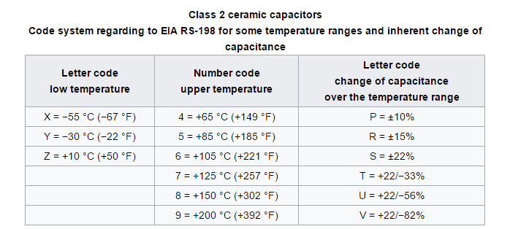

Bypass capacitors
These capacitors must be added to delete current spikes in the pins (normally the ones used for controlling the mosfets). This way the current is dumped with a polarized capacitor connected to ground. They are also added as close as possible to the IC lines to delete frequencies near sensitive pins.

ESP32 Module
The ESP32 WROOM parameter N4, N8, N16 determines the amount of RAM, same footprint. WROOM includes on board antenna while WROOM – 1U requires an external one. The ESP32 S3 module includes 2 separate sub processors enabling simultaneous threading.

Comms Protocols

SPI
4 wires required: MISO / MOSI / CS / SCK – As it has a line for input and another one for output, full duplex communication is possible, and several slaves can enter the line. It has greater speed than SSI, with configurable clock polarity, and flexibility.

SSI
3 / 4 wires required: SCK / SDO / SDI (CS possible) – It only supports one master – slave pair. It has lower speed, fixed clock polarity and is used in industrial applications.

I2C
Wires required: SCL / SDA (better for various masters / short distances, PCB). Both signals (resistor per line and I2C number) must include pull up resistors (1,8k best performance, 4,7k recommended for typical 3v3 – 5v).
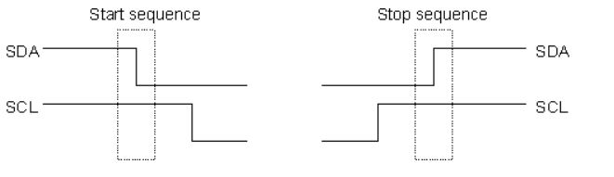
Start and Stop sequences are the only moments in which the SDA is allowed to change while SCL is high.

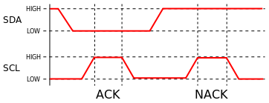
Data is transferred in sequences of 9 bits (8 data bits + ACK bit). 9 SCL pulses to transmit 8 data bits.

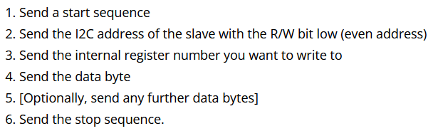
Recommended transmission speed of 100KHz or less. The 8 data bits include 7 bits for address and a R/W bit (if 0 master is writing to the slave, if 1 master is reading from the slave). This way we can include up to 128 devices on the I2C bus. The R/W is the last data bit, leading the address to be odd or even.
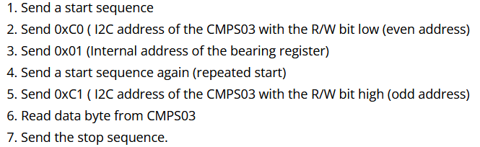

The characters “0x” refer to the following number written in hexadecimal. Therefore, 0x3C will be 00111100.
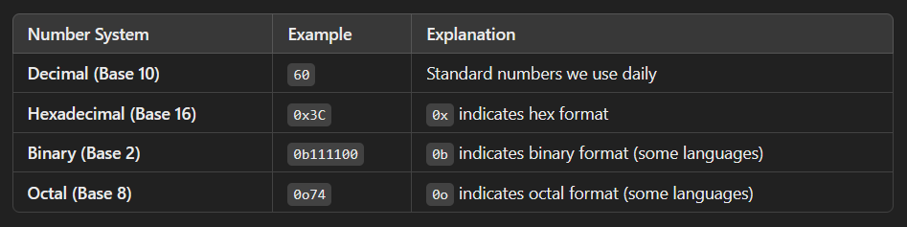

CAN
This bus requires a resistor in both ends of the wire loop, this way a jumper possibility must be included in each of the nodes so that it acts as an endpoint or not. This termination resistors (120 Ω each) must have the jumper at both sides of the resistor to modify its behavior. Only 2 cables are needed, CAN_H and CAN_L.
CAN drivers as SN65HVD232DR is required.

UART
The UART (Universal Asynchronous Receiver/Transmitter), exchanges a bit at a time (asynchronously, without sharing a clock between devices). It allows transmitting and receiving at the same time by using a start and stop bit. The pins used are Tx, Rx and GND. Both devices must agree in having the same UART configuration. The Baud rates is related with the amount of signal changes (bit) transmitted per second (9600, 19200, 38400…). To communicate through a USB with UART, a converter as CH340 or CP2102 is required except the MCU already includes one (as the ESP32 S3).
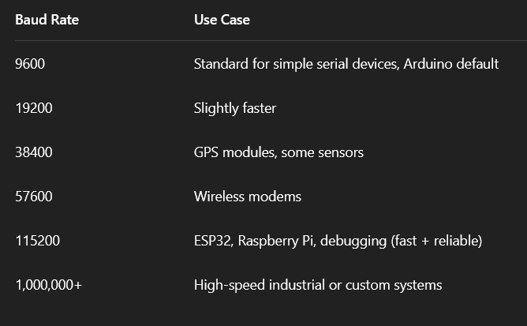

Differential Pairs
Implementing differential pairs for sensitive signals helps us to ignore the ground voltage offsets, useful for signals travelling long distances and other interfaces (USB, Clocks…). Twisted pair (cables) will counter noise as it will affect equally both lines, it also ignores 3D ground offsets.
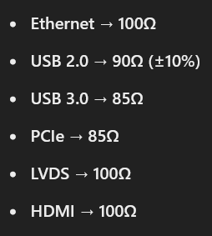
Zdiff (differential impedance) = 2 * (Z0 – Zcoupling) -> Close traces increase Zcoupling, wide traces increase Z0 to reference plane.
Depending on the diff pair we are working with, a specific value for Zdiff may be required. These values are considered for the sum of both traces. We can obtain single-ended track width with these values. Recommended to start with single-ended track Z (width) and then go to Zdiff to adjust the spacing.
Skew (timing mismatch) between diff pairs traces (intra-pair) should be < 5ps. Skew between different sets of diff pairs from the same group < 100 or 1000 ps (inter-pair).

Circuit protection

Over-current
DC Current battery measurement
To protect the MCU from excessive current, a polyfuse should be added in the Vbus from the USB. It limits the current in a circuit, increasing the resistance it limits the current flow. It automatically resets when current goes back to normal.

Over-voltage
DC-Link Voltage and Battery Voltage measurement.
Recommended resistor to dump the excessive power generated by the motor feedback. This resistor tends to be 81ohm but with a higher Watt value.
In case of overvoltage, we can introduce a comparator with a Vref, if it goes over that reference, the device will need to disconnect to protect the components, therefore a TRIAC crowbar will short to ground the battery and a resettable fuse will pop resetting the board from any wrong function.

Over-temperature

Under-voltage

Reverse-polarity (RPP)
The PMEG3020 Schottky diode allows 30V of reverse voltage limit, handling up to 2A of continuous current. It is a good option for DC-DC converters as it has a high switching velocity.
Diodes are placed connected to ground so in case the current flows in the opposite direction, all voltage will drop to ground. Remember to place correctly the diode so that in forward mode the current is not redirected to ground.
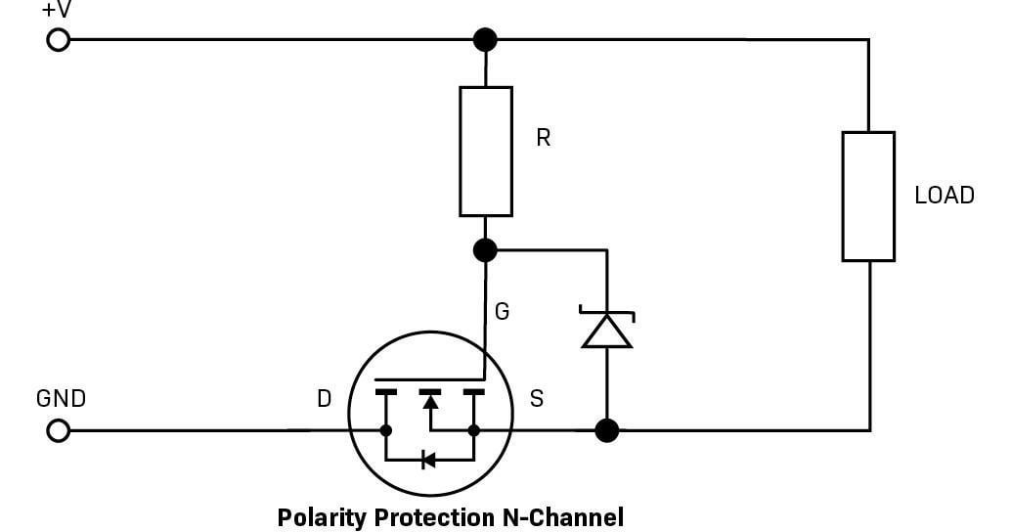
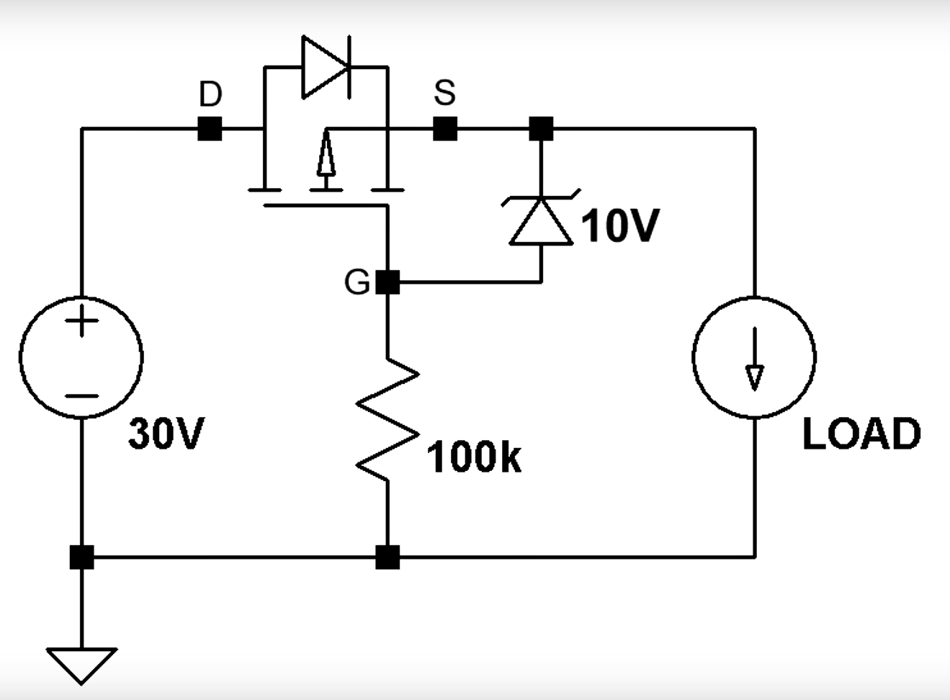
Diodes for Reverse polarity protection will constantly consume power as current passes through them. There are different alternatives by using mosfets that will dump power losses. The P-Channel mosfet circuit blocks when a negative voltage value appears at Drain, therefore Vgs > - Vbreakdown. We can include Schottky/Zener diodes in series connected to ground with a resistor, increasing the maximum allowed gate – source voltage (attending to power source specs).
The same is applied for N channel mosfets (NMOS) reverse polarity protection circuits. However, in this case the GND of the PCB won’t be a true ground (> 0V) and it can’t be attached to a main ground plane, a Zener diode can be used to enhance the circuit capabilities.
The value of the resistor is obtained with the formula (V input – V Zener / I (test current Zener) + I Load). The Zener diode datasheet will provide a minimum current (mA) to keep it in breakdown zone.
There is no need to include a resistor and Zener diode if we can ensure that the transient / inductive spikes of the circuit wont go over the max Vgs value, taking into account the lowest Rds value.
It is important to search for low Rds mosfets as the lower the resistance when active, the lower the power losses and temperature of the mosfets, otherwise the mosfets may not withstand the high temperature. Ensure the mosfets works in the active region to reduce the value of Rds.

ESD and TVS (electrostatic discharge)
The LESD5D5 is an ESD protection diode that protects the circuit from transient voltage spikes. It only supports until 5V with a current of 5A. It is not suitable for power line protection but for communication lines. The TVS selected for the Vbus line was the PESDNC2 with a Vrwm of 5V and up to 6A of current.
For metallic robots, it is recommended to include a big resistor (1Mohm) from GND (pad) to the chassis helping electrostatic energy dissipation.
A ESD channel is required for each power line that reaches the MCU. For example, for a USB connector we need 3 lines (D_P, D_N and Vbus).
ESD refers to the electrostatic discharge generated when a charged object or ground plane touches sensitive component of the circuit. This may damage certain components as mosfets by inducing a high voltage spike.
TV (transient voltage) events are generated by inductive components as motors. They induce a higher current but lower voltage spike than ESD.
There are single TVS diodes and IC for ESD protection which include several lines. Single TVS diodes allow for greater current protection while IC ones are more compact and tend to protect better higher voltage spikes. Depending on the number of signal lines you want to protect and the space available, one of these options will be selected. For proper signal integrity after passing through the ESD protection IC, it is preferred to have low capacitance values (datasheet). The reverse working maximum voltage (standoff voltage, Vrwm) refers to the value that will trigger the ESD event (ex. 24V or 5V). Inductive loads generated by motors induce a voltage drop (negative voltage wave) that flows back to the power supply. This extra voltage should be considered when selecting the standoff voltage.
The clamping voltage refers to the maximum supported voltage by the ESD IC.
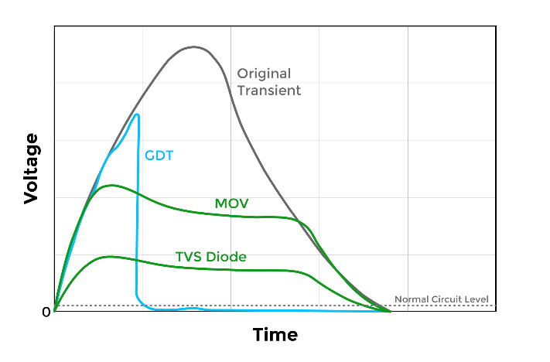
There are unidirectional and bidirectional ESD protection components. The unidirectional TVS diodes are used for UART, SPI or DC power lines where the voltage goes from 0V to VCC (no possible negative values). The bidirectional TVS diodes are used for USB or CAN lines where the voltage swings from positive to negative values. These diodes tend to have low clamping voltage and capacitance values.

Back-EMF (Electromotive force)
BLDC motors typically generate back AC voltage ripples opposing the supply. These ripples tend to be higher when rapid load changes, motor speed changes or switching PWM noise. It affects communication lines (EMI), generates stress to motor drivers, creates noise at the sensors…
Electrolytic capacitors help as reservoirs for sudden power demand, stable dc voltage supply… The characteristics of these capacitors must include double the max voltage supply allowed, high capacitance value depending on the current ripple needs and low ESR (equivalent series resistance) allowing smoothing fast changes. Typical values can be 470uF and several placed in parallel will store more power. They should be helped by ceramic capacitors for high-frequency filtering.

Power supply

USB-C
The faster the USB lines, the better the differential pairs should be designed (impedance). It is recommended a diff impedance of 90ohm. Include always filled ground plane under diff pairs. Usb_N and Usb_P.
A bridge filter with several parallel capacitors should be used to filter the battery voltage input. Ceramic capacitors will dump high frequency noise and electrolytic or polarized ones the lower frequencies. An inductor is placed to resist the back energy from the motor, avoiding it reaching the battery lines.
USB 2.0 allows 60 Mb/s and one way communication, whereas USB 3.0 allows 600Mb/s and 2-way communication. The number of pins refers to the number of things we want to use the USB for. 12 pins for simple data and power, 16 pin for UART comms and power, and the 24 pin for high-speed data or video display.
The USB Type-C includes 2 data wires D- and D+ (diff pairs). The shield is grounded and the Vbus is the main power source pin. The USB type-C socket needs to have both CC pins configured with pulled-down resistor so that it will work in both cable orientation. The CC pins allow for cable orientation detection, role negotiation and current limitation. The current value will be determined by the value of each resistor.
5V – 500mA -> 5,1 kΩ pull-down
5V – 1,5A -> 2,5 kΩ pull-down
5V – 3A -> 1,5 kΩ pull-down
Cascade power connection refers to the connection of several motors in parallel. Two connectors are added to each side of the PCB, reducing the number of cables to only 2 general power lines.
To avoid EMI noise, we want to have a low inductance connection between the pin SHIELD and GND, a resistor of 1M ohm may be used to prevent ground loops (USB are not likely).

Linear Regulator
These voltage regulators allow us to obtain a lower output voltage from a higher input range (step-down). Some examples can be the LM7805 (7V-35V to 5V with 1A), the LP2985 (2,5V-16V to 1,8V-5V with 150mA) or the MPM3612 (4,5V-21V to 0,6V-12V with 2A).
The LP2992 regulator (5V -> 3,3V) includes an ON/OFF pin, (pull up for proper functioning) it allows to drop current consumption during shutdown hold.
However, linear regulators tend to be less efficient than other options having a significant dropout voltage as heat. The easy, compact and cheap design are the main advantages. For large voltage drops, it is recommended to use a buck-converter. If we need to convert 12V-5V-3,3V a LDO will be included for the small 5V-3,3V drop.
All voltage regulators must have the ability to change the output Vbus voltage by changing a resistor, twisting a potentiometer or by code. For example, the CH224k (5V-20V with 3A). These limits should be considered when defining the motor requirements.

Buck Converter/Step down regulator

Component selection
Attending to the frequency value, the size of the required components will change. For higher frequencies, the components will be smaller, with faster response, better filtering and low frequency ripples but with higher losses, worse efficiency and EMI. Lower frequencies will mean bigger components (less compact).
Duty cycle: δ = Vout / (Vin (max) * Efficiency)
Inductor Ripple Current: ∆I = (∆Vin,out * δ) / freq * L (average datasheet)
Check required current output: I (IC, max) = Current limit (data) – Inductor Ripple Current / 2
Switching current = I (output load) + Inductor Ripple Current / 2
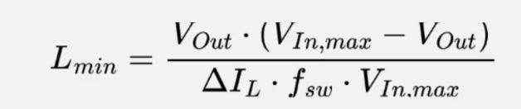
To select the proper value for an inductor, we use the following equation:
We estimate the ripple current value to be between a 20% and a 40% of the max output current. The value of the inductor obtained will be the minimum one for our buck, the inductor will need to support at least the switching current.
For the diode selection, it should be a Schottky one with a current rating of at least
I = Output current * (1- δ)
Remember to check also the power ratings of the diode.
For selecting the proper capacitors, they should have a low ESR (equiv series resist) and high temperature ratings. The typical values are given in the datasheet.
For selecting the output resistors, we should take 10k-100k value ones. The tolerance shouldn’t be over 1%. If we are using high frequency components, they should be 0603 or smaller (tolerance importance).

ME3116
Component characteristics:
- Wide Input Voltage Range: Operates from 4.75V to 40V, accommodating various power sources.
- Fixed Output Voltage: Provides a stable 5V output, suitable for numerous electronic applications.
- High Efficiency: Achieves up to 90% efficiency, minimizing energy loss and heat generation.
- Output Current Capability: Delivers up to 1A of continuous output current, supporting moderate power loads.
- Integrated Protection Features: Includes safeguards against reverse voltage, overcurrent, undervoltage, and current spikes, enhancing reliability.

TP6841S6
Component characteristics:
- Input Voltage Range from 4,5V to 40V, controllable Vout
- Continuous output current of up to 0,8A
- High efficiency with up to 95%, external components and inductor required
- No Schottky diode required, included short-circuit, over-current, Vin under-voltage, shutdown mode, protection
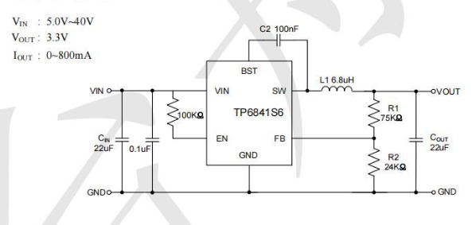

MCP73832
Battery charge management controller:
- Input voltage between 3.75V to 6V (regulated internally).
- If battery below 2,8V it charges at 10% programmed current
- Program current at pin PROG (Current charge = 1000V / R prog) to ground.
- Max 500 mA charge current for a single cell
- STAT pin indicates status, low (charging), high (charge complete), flashing (error). Led from 5V to STAT pin as GND.
- Charges batteries up to 4,2V

Mosfets and drivers
There are 2 types of mosfets, logic level and power ones. Logic level mosfets have a voltage D-S range from 0 to 5V (recommended to use pin directly to avoid energy losses).

N-Channel
An external gate resistor is needed between the mosfets and the gate driver, too high resistance can lead to high power dissipation and less speed, and too low resistance to V overshoot, gate ringing, instability issues and EMI (electromagnetic interference). This resistor will overheat easily therefore a large area is needed for them.
A resistance is always required between the gate and the pin, otherwise the current will not have a limit, going through the internal inductor and generating big voltage peaks. This resistor will determine the mosfets switching speed. A pull-down resistor will ensure a default off position. By placing different resistors, we can determine different ON or OFF speeds.
The mosfets always have an internal capacitance between the gate and source that will increase the time between switching ON/OFF. Also, an internal inductor in the gate will generate excessive voltage peaks when the mosfet is disconnected if there is not gate resistor. This ringing can make the mosfets get on or off when not wanted.
An internal source inductance appears and can pass the effect to the one in the gate, to mitigate this an extra pin called Kelvin source connection.
There is also a drain inductance dependent on the pcb layout. For H-bridge we want to minimize the inductance created by the loop (loop inductance) of the external capacitor and both mosfets.
To minimize the area (inductance) between the Gate and Source traces, we can run the gate trace from gate driver to mosfets and in the layer below the Source one. Also, try to separate as much as possible the power loop (drain source) from the gate loop.

P-Channel
They tend to be less efficient to conduct current by the same voltage applied. The current flows when Vgs < Vth.
The FET transistors are better than the mosfets in the way that they are less vulnerable to electrostatic electricity.

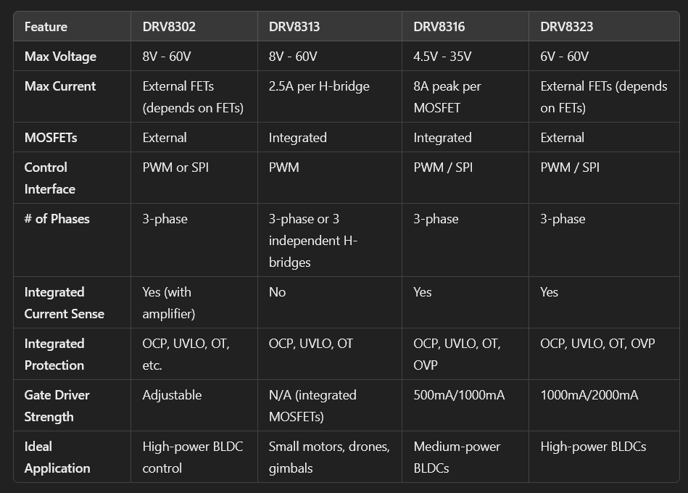
DRV8302/13/16/23

External mosfets allow better control and deletes the imposed current limit. DRV8323 is widely used with the MIT Mini Cheetah library.

NCP81074A Mosfet Driver
It allows to switch mosfets states in a control mode. OUTH and OUTL pins allow the control of the switching ON and OFF speeds by placing different gate resistors.
Important specs:
- Continuous current value
- Max stall current (given by the motor)
- Audible range of operation (preferred to be ultrasonic)
- Heat dissipation, obtained from the Rds Max. Junction to ambient resistance will return us the change in temperature of the mosfet per unit of power.
- Mosfet Vgs is aligned with the OUT-voltage pin of the driver
- Charge to reach activated level Q
To obtain the switching velocity of the mosfet we compute the current through the gate resistor when a certain voltage is applied. The switching time equals the required charge to fill the mosfet capacitor up to operating level, divided by the gate resistor current.
TB67H450FNG
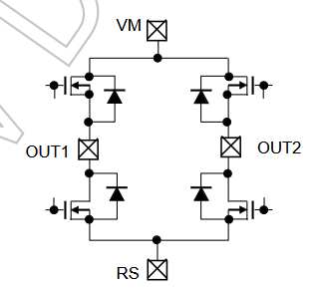
Dual H-bridge motor driver designed for DC brushed motors and stepper motors. The operating voltage goes from 4,5V to 44V with a continuous current of 3,5A (4,5A peak). The compact form includes built-in protections against voltage, current and temperature.
It includes forward, reverse and break mode depending on the input pins IN1 and IN2. The output pins OUT1 and OUT2 are placed in the middle of the H-bridge so when connecting the current will flow in one or other direction. The maximum output current is selected by defining the Vref and RRS resistor values.
PCA9685 PWM Generator
The use of a PWM generator is recommended when we cannot provide enough frequency with our MCU. We obtain better accuracy, stability, less MCU resource consumption and up to 16 PWM outputs. It isolates the PWM signal from the main circuit reducing noise. OE pin to ground to enable output.

Specs
Voltage rating: 16V
DRV8302 (TPS54160 Buck Converter IC)
Integrated Buck Converter: Max 1.5 A
RPP, Over Volt. Protection, TVS
Gate driver protection 8-16V (under and over)
PVDD: 8 – 60V
40Mhz Internal Osc

Current consumption:
- MCU – 360 mAh
- Mag. Sensor – 5 mAh
- IMU – 1 mAh
- RTD – 5 mAh
- 3 x Gate – 90 mAh

DRV8302
3 phase gate driver pins
- GL and GH for low and high gates of the mosfets.
- SH as switch pin between low and high gates, SL as low side reference.
- SN and SP as differential low side current sensing pairs (Only 2 coils, tot currents = 0)
- INH, INL are PWM inputs from the MCU for the mosfets.
- DC_CAL to calibrate the shunt resistors (current sensing) (Better during switch off). Common Voffset of Vref/2. The GAIN can be set as 10V/V or 40V/V from Gain pin (LOW / HIGH).
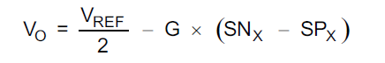

The Vref is set with the REF pin connected to an ADC
- The output of the current amplifier exits the gate driver through the SO1 and SO2 pins.
- NFault pin driven low when fault ocurrs (over voltage, under voltage…). To reset, EN pulse required.
- Noct pin works as the Nfault but it detects overcurrent. No reset needed, resets automatically after 64 us. Page 18 all warnings.
- M_OC pin, when overcurrent event if LOW -> cycle by cycle limit, if HIGH -> shutdown
- M_PWM pin, if low 6 indep PWM inputs (need to control duty cycle, both H and L sides), if high 3 indep PWM inputs (DRV in charge of L side).
- DTC pin for dead time control, delay between turning off and on the following mosfet.
- EN_GATE pin LOW (save energy mode, MOSFET high impedance), HIGH (power up enable mode). HIGH to LOW (shutdown immediately). Reset pulse is HIGH LOW HIGH with a duration of 10 – 20 us. For GVDD_OV, it is required to hold for more than 20us to reset (recommended to inspect system first).
- OC_ADJ pin sets the limit value for VDS, over which the overcurrent protection will activate. In our case we set the max current for the mosfets to 40A, 2.4 mΩ RDS(on), Vds = 0.1V

2. Firmware

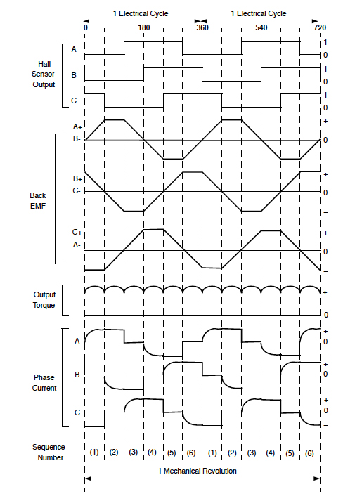
2.1 BLDC Control
Each time a coil is turned ON, the high side of a bridge will be ON and the low side of another bridge also. This way we need to have 2 powered mosfets at each time.
The extra wire that is not being used when the other coils are powered can be used to measure the Back-EMF, this way we obtain a hall sensor in this coil. By using a comparator to measure the voltage across the winding we can detect whether it is time to change to the next position or not. This will allow us to obtain better torque and proper motor start up.
The comparator is placed from the measuring coil to the common coil. Some motors include a 4th wire with the common coil, if not we should connect a resistor to each coil and connect them together to obtain this common point. The value of these resistors is high >30k to limit the current passing by. The voltage value of the common point will be the sum of the 3 coil voltages.
When the Back EMF crosses the 0 line is called “0 cross detection”. This point is where we need to make the coil change (step). We will detect when the coil passes by this value by comparing its voltage with the total coil one (Common).
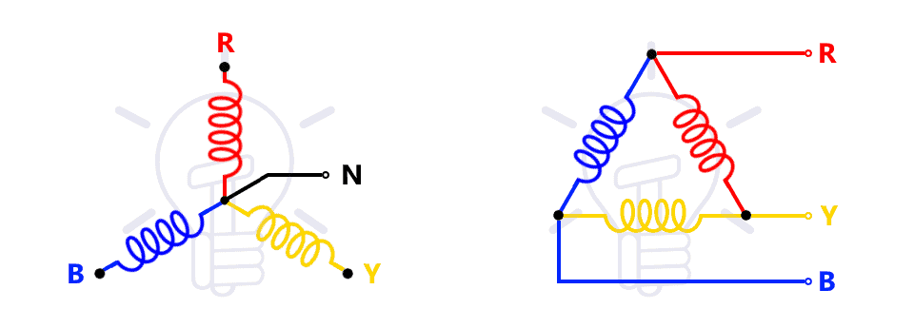
Before the comparator, a voltage divider is used to ensure the measured voltage is in the range of the MCU. This way we can lower the voltage of the Back EMF (over VCC ~ 15V) to a range of 3 or 5V. The resistors must be calibrated for each input voltage.
Parallel diodes to each mosfets should be added to prevent reverse voltage across the mosfets.
Typical configuration includes a high and low mosfets to create a H-bridge configuration for each of the 3 coils, resulting in a total of 6 mosfets. However, this can be seen in parallel to gain more power per coil.
The mosfets SVPWM switching control makes variable field control. Reducing vibration and improving position control.

2.2 Open-Loop control

2.3 Closed-Loop control

Torque
Also known as current controller, controls the required current in the motor to overcome the dynamic load changes.

Speed
This controller is kept behind the torque one as it will tell the torque controller the small shift needed to maintain a constant speed.

Position
Last controller to be tuned, it tries to position the motor in an exact angle

Magnetizing current controller
Required to control the magnetizing current for BLDC FOC.
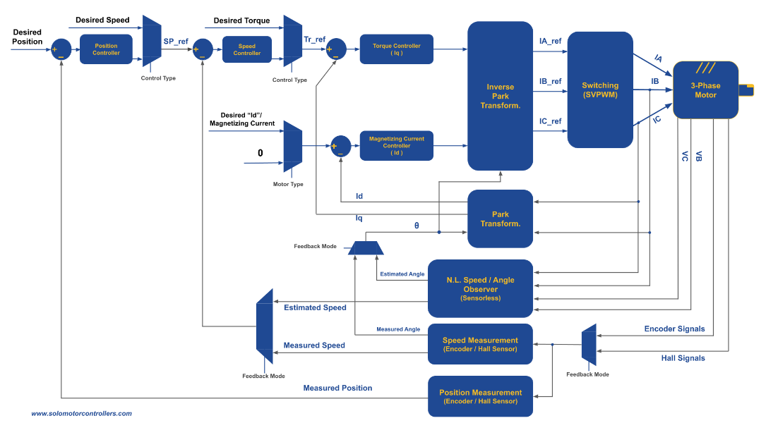

Motor tuning

3. Mechanical

The common female pins are SH 1.0 and “num pins”P , this cable may be used for CAN or other protocol connections.
The Arduino common pins – Header 2,54 mm
The battery connectors are the XT 30, 60, 90 attending to the supported max current.
The jumper port connectors must have the possibility to include an entry component (prev) and the following one, for protocol connections. JST connectors for multiple line connections.
Test points for signals and voltages should be included.
Include pin for battery control, voltage consumption.

Motor tuning
Physical potentiometers can be added to control the Kp, Ki and Kv constants manually without any software requirement.

4. Future upgrades
Break control + Resistors

5. Links

NEMA Controllers
Dummy robotic arm
https://www.youtube.com/watch?v=F29vrvUwqS4&t=1s
https://github.com/peng-zhihui/Dummy-Robot
Motor driver – Dummy robot (full schematic)
https://github.com/peng-zhihui/Dummy-Robot/tree/main/1.Hardware/MotorDriver-20
https://github.com/peng-zhihui/Dummy-Robot/blob/main/1.Hardware/MotorDriver-42/Motor-42.pdf
Stepper driver and controller (full schematic)
https://github.com/joshr120/PD-Stepper
https://www.youtube.com/watch?v=qECEGUZE04s&t=29s
Commercial CLoop Nema 17 (overview of conns)
https://creapunk.com/hardware/
https://github.com/creapunk/CLN-ClosedLoopNemaDriver/blob/main/hardware/CLN17/V2.0/CLN17-V2.0-SCH.pdf

BLDC Controllers
Biped robot channel (ESP32)
https://www.youtube.com/@QihaoGuo/videos
ODRIVE Controller
https://docs.odriverobotics.com/v/latest/hardware/pro-datasheet.html
STM32 BLDC Controller (full tutorial)
https://deepbluembedded.com/stm32-esc-pcb-design-foc-esc-bldc-schematic/
ElectroNoobs Arduino BLDC Controller
https://www.youtube.com/watch?v=VdkloigaxZo

BLDC Control Loops
https://docs.odriverobotics.com/v/latest/manual/control.html#position-control-loop
Simulink FOC Control
https://www.youtube.com/watch?v=ilN-DauXVFM&t=266s

Battery power
ESP32 robot with integrated battery
https://github.com/StuckAtPrototype/Racer
MQ ONE
https://mquero.com/projects/MQOne

Sensors

